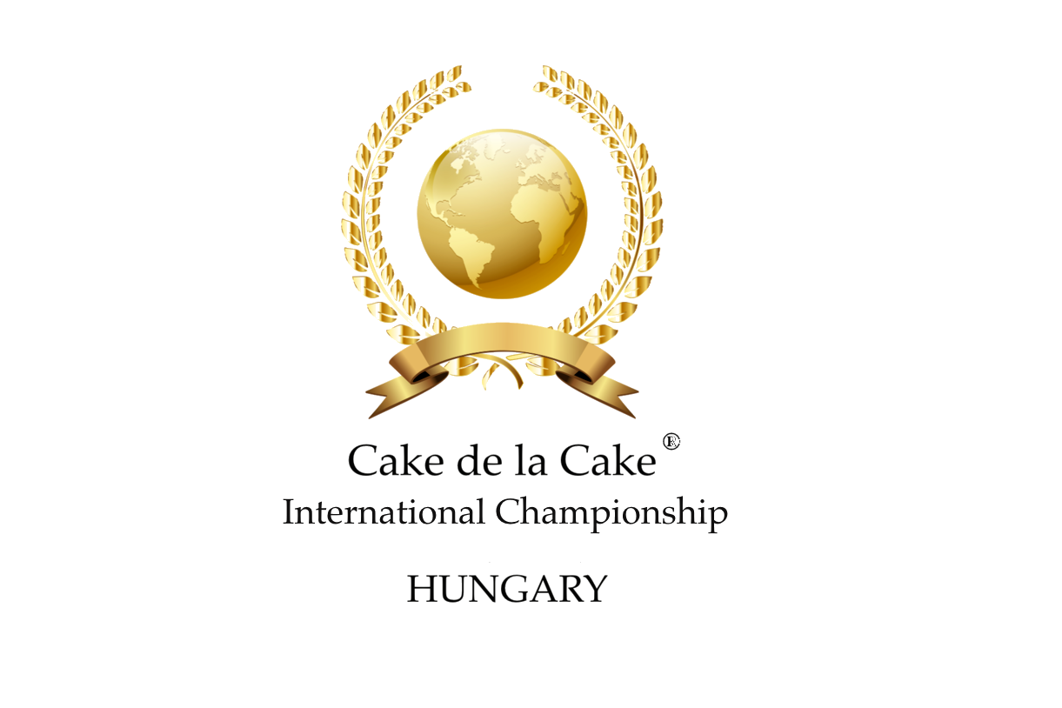

Championship Categories

|  |
| --- |
| A1. Buttercream Covered Cakes |
| A2. Sugarpaste Covered Cakes |
| B. Sculpted Cakes |
| C1. Plate Desserts – Amateur |
| C2. Plate Desserts – Professional |
| D. Macaron |
| E. Free From Cakes |
| F. Master Pastry and Patisserie Business |
| G. Sugar Flowers Display |
| H. Small Artistic Display |
| I. Large Artistic Display |
| J. Royal Iced Cakes |
| K. Royal Iced and Sugarpaste Decorated Cookies |
| L. Wedding Cakes |
| M. Children Category |
| N. Artistic Display – Junior Pastry Chef (College Student) |
| O. CDLC Sponsorship – Sugar Flowers |
| P. CDLC Sponsorship – Small Artistic Display |
| Q. CDLC Sponsorship – Wedding Cakes |
| R. CDLC Sponsorship – Junior Pastry Chef (College Student) |
| S. CDLC Sponsorship - IKA Olympics Germany 2024 – Small Artistic Display – Professional |
| T. CDLC Sponsorship – IKA Olympics Germany 2024 - Junior Pastry Chef (College Student) |

Edible Categories

**A1. Buttercream Covered Cakes**

* In this category we welcome any tiered cakes with any design and flavour.
* It is fully up to the contestants how they would like to dazzle the judges with their creativity and imagination.
* Please note that in this category the cake will go under flavour tasting (only one tier what the judges will cut into).
* It is the contestant's responsibility to give a mark/note to the judges that which tier should go under tasting, if the competitor forgets to indicate the tier, then the jury will choose one.
* Please don't use Styrofoam base in this category, because the cake will undergo a tasting test, therefore you will get a chance to win “The Best Tasting Cake” award.
* We would like to highlight that the overall impression, technical execution also important and will be judged.
* Please don’t forget to indicate the ingredients (list) for to avoid allergic reaction.

**A2. Sugarpaste Covered Cakes**

* In this category we welcome any tiered cakes and you can freely choose from any standard shapes such as round, square, cube, rectangle, hexagon, etc.
* The cake has to be 100% edible (except the dowels or any other supporting elements).
* Please don't use Styrofoam base in this category, because the cake will undergo a tasting test, therefore you will get a chance to win “The Best Tasting Cake” award.
* If the tiers have different flavours, then we ask that to place a small sign to indicate which tier should go under the tasting test.
* If the competitor forgets to indicate the tier, then the jury will choose one.
* We would like to highlight that the overall impression, technical execution also important and will be judged.
* Please don’t forget to indicate the ingredients (list) for to avoid allergic reaction.



**B. Sculpted Cakes**

* In this category we welcome any different form-cut, carved and shaped creations. Internal support is allowed to use, but we would like to ask to follow the Health and Safety Regulations as the cake can be sold to the public.
* The cake has to be 80% edible, the rest of the 20% can be Rice Krispies Treats or cake dummy (Styrofoam).
* The cake will go under tasting test.
* Any shape and height allowed within a 60x60cm base.
* All materials must be edible and suitable for human consumption, except internal supports and/or cake dummy.
* Please don’t forget to indicate the ingredients (list) for to avoid allergic reaction.

**C1. Plate Desserts – Amateur**

* The competition piece should contain at least 4 different elements:

-fruit -gel -cream -crunch

* The competitor has to present 4 pieces on 4 plates for the tasting test.
* The presentation and display area decoration is the contestant’s responsibility.
* The judges expect use of modern techniques such as mirror glaze, velvety texture etc.
* The judges also expect description of the competition piece, the food colouring technologies, gelling methods and any use of healthy alternatives.
* Please don’t forget to indicate the ingredients (list) for to avoid allergic reaction.

**C2. Plate Desserts - Professional**

* The competition piece should contain at least 5 different elements:

-fruit -chocolate -gel -cream -crunch

* The competitor has to present 4 pieces on 4 plates for the tasting test.
* The presentation and display area decoration is the contestant’s responsibility.
* The judges expect use of modern techniques such as mirror glaze, velvety texture etc.
* The judges also expect description of the competition piece, the food colouring technologies, gelling methods and any use of healthy alternatives.
* Please don’t forget to indicate the ingredients (list) for to avoid allergic reaction.

**D. Macaron**

* We would like to see a macaron display that contains minimum 30 pieces, this should include 20 pieces of 1,5 inch (not decorated, regular) and 10 pieces of 2 inch (with different wedding design) hand-painted and/or decorated, which fits in a 40cm x 40 cm base.
* Feel free to make more than 30 pieces in total with different sizes and shapes.
* For display purpose only non-edible stands, displays, Styrofoam cones, decorative elements etc. are allowed to use.
* They will be tested for regularity and appearance as well.
* Please pay attention for standard sizes etc.
* Also they will go under taste testing, so we kindly ask you to place 5 out of the regular sized macarons on 5 different plates for the judges.
* The theme: Wedding table
* Please don’t forget to indicate the ingredients (list) for to avoid allergic reaction.

**E. Free From Cakes**

* We are looking for innovative sweet “solutions” cakes that can be consumed with gluten sensitivity, dairy-free, egg-free, flour-free, soy-free, nut-free etc.
* Free to choose the taste combinations and the flank of allergy, the point is to have at least an allergy included.
* We are expecting ten pieces of sweet cake compositions in this category.
* Presentation and decoration is the competitor’s task.
* Also they will go under taste testing, so we kindly ask you to place 3 slices out on 3 different plates for the judges.
* We also asking for the indication of the "ingredients used" list in order to avoid allergic reactions.

# F. Master Pastry and Patisserie Business

* We expecting entries of Hotels and Hospitality units, Cakery, Bakery, Cake Shops, Pastry Shops or Patisseries in this category.
* We would like you to present a 10 pieces display of your shop's signature dish.
* We will also require a short introduction of your shop, the recipe of your dish with a technological description (in email).
* We will award 1st, 2nd and 3rd places with cash prize in this category!
* The winner will receive The Master Pastry and Patisserie Business of the Year 2020 title.
* Please don’t forget to indicate the ingredients (list) for the tasting judges for to avoid allergic reaction!

**Please note:**

**In the edible categories, the entries will go under taste tasting! In most of these categories artificial elements are not allowed to be used.**

Non-Edible Categories

**G. Sugar Flowers Display**

* The flower bouquet/display must be a minimum of 7 pieces of flowers composition, which does not exceed a maximum of 40x40cm base.
* No height limitation.
* The flowers are must be botanically correct.
* We would like to highlight the importance of the veining of the petals, leaves and proportion.
* Colour harmony and balance is also important.
* Flower buds and filling flowers do not count as full-flowered flowers. In each composition at least 2 different types of flowers should be used.
* Use of stigma and thread in the middle part is permitted, but false leaves are not.
* We recommend the attention and focus on the correct sizes, for colour use and consistency on overall impact.



**H. Small Artistic Display**

* In this category, welcome any shape, size and theme of the little statues/figurines or statue groups, which fit into a 30x30x30cm cube.
* Internal support is allowed, but external is not.
* Also use of Styrofoam is allowed, but all of the covering and decorating elements must be made of edible materials that suitable for human consumption.
* The judges looking for a unique designs of a chocolate, sugar, marzipan or tragant creations where specially made decorative techniques were used and spatial-3dimensional artistic creations.

**I. Large Artistic Display**

* In this category, we welcome any shape, size and themed statues/figurines or statue groups, which must fit a 60x60cm base.
* No height limitation, internal support is allowed, but external not.
* Use of Styrofoam base permitted, minor lighting and sound effects may be used but, of course, do not over dominate the completion piece.
* Every covering and decorative elements has to be suitable for human consumption.
* The judges looking for a unique designs of a chocolate, sugar, marzipan or tragant creations where specially made decorative techniques were used and spatial-3dimentional artistic creations.

**J. Royal Iced Cakes**

* In this category we welcome a minimum 2 tier Styrofoam (dummy cake), which only covered with Royal Icing.
* The display area is up to a 30x30cm; the cake drum has to be glazed with Royal Icing, also all decorative items must be made of Royal Icing as well.
* Materials and decorations that are not suitable for human consumption are not allowed to use. T
* here no height limitations, internal support is allowed, but external is not. It is fully up to the contestants how they would like to dazzle the judges with presentation and their creativity.
* Please note that, in this category the overall impression, technical execution will be judged as well.

**K. Royal Iced and Sugarpaste Decorated Cookies**

* In this category we expect a 10 pieces of cookie collection which glazed with Royal Icing or covered/decorated with sugarpaste.
* The collection has to have the same theme, but each cookie has a different design. All cookies have to be 100% edible. Non edible materials and decorations are not permitted.
* The display has to fit in a 30cmx30cm area.
* Non-edible racks and display elements are allowed, but only for presentation purposes. There no height limitations.
* The cookies thickness can be between 5mm - 1cm without decoration! The theme is up to the contestant’s choice.

**L. Wedding Cakes**

* In this category we welcome any minimum 3 tiered Styrofoam (cake dummy) with any wedding designs that fits in a 45x45cm base.
* There’s no height limitation. It is fully up to the contestants how they would like to dazzle the judges with their creativity and imagination.
* Cake stands and separators are permitted to use.
* Floral wires and armatures are permitted to be used.
* Also use of florist tape to wrap wires, and posy pick or plastic holder equipped for flowers or other quillwork/decorative items that can be fit to the cake.
* Contestants please note that in this category the overall impression, technical execution will be judged too.

**M. Children Category**

* In this category we are welcome any child contestant aged between 9-14.
* Competitors have to bring a piece of pre-decorated Styrofoam cake, that entirely finished (covered and decorated at home).
* The choice of theme and decoration is fully up to the competitor, but the base (cake board) should not exceed 30x30cm.
* No height limitations. Internal support is permitted but external not.
* Every covering and decorative element has to be suitable for human consumption.



**N. Artistic Display – Junior Pastry Chef (College Student)**

* In this category, welcome any shape, size and theme of the little statues/figurines or statue groups, which fit into a 60x60cm area.
* Internal support is allowed, but external is not.
* Also use of Styrofoam is allowed, but all of the covering and decorating elements must be made of edible materials that suitable for human consumption.
* The judges looking for a unique designs of a chocolate, sugar, marzipan, isomalt or tragant creations where specially made decorative techniques were used and spatial-3dimensional artistic creations.
* This is the category we favour those contestants, who are aged between 14-19, and are pastry students at college.
* We looking for only their registration.

**O. CDLC Sponsorship – Sugar Flowers**

* The flower bouquet/display must be a minimum of 7 pieces of flowers composition, which does not exceed a maximum of 40x40cm base.
* No height limitation.
* The flowers are must be botanically correct.
* We would like to highlight the importance of the veining of the petals, leaves and proportion.
* Colour harmony and balance is also important.
* Flower buds and filling flowers do not count as full-flowered flowers.
* In each composition at least 2 different types of flowers should be used.
* Use of stigma and thread in the middle part is permitted, but false leaves are not.
* We recommend the attention and focus on the correct sizes, for colour use and consistency on overall impact.
* **The winner of this category will receive a £400 cash prize.**



**P. CDLC Sponsorship – Small Artistic Display**

* In this category, welcome any shape, size and theme of the little statues/figurines or statue groups, which fit into a 30x30x30cm cube.
* Internal support is allowed, but external is not.
* Also use of Styrofoam is allowed, but all of the covering and decorating elements must be made of edible materials that suitable for human consumption.
* The judges looking for a unique designs of a chocolate, sugar, marzipan or tragant creations where specially made decorative techniques were used and spatial-3dimensional artistic creations.
* **The winner of this category will receive a £400 cash prize.**

**Q. CDLC Sponsorship – Wedding Cakes**

* In this category we welcome any minimum 3 tiered Styrofoam (cake dummy) with any wedding designs that fits in a 45x45cm base.
* There is no height limitation.
* It is fully up to the contestants how they would like to dazzle the judges with their creativity and imagination.
* Cake stands and separators are permitted to use.
* Floral wires and armatures are permitted to be used.
* Also use of florist tape to wrap wires, and posy pick or plastic holder equipped for flowers or other quillwork/decorative items that can be fit to the cake.
* Contestants please note that in this category the overall impression, technical execution will be judged too.
* **The winner of this category will receive a £400 cash prize.**

**R. CDLC Sponsorship – Junior Pastry Chef (College Student)**

* In this category, welcome any shape, size and theme of the little statues/figurines or statue groups, which fit into a 30x30x30cm cube. Internal support is allowed, but external is not.
* Also use of Styrofoam is allowed, but all of the covering and decorating elements must be made of edible materials that suitable for human consumption.
* The judges looking for a unique designs of a chocolate, sugar, marzipan, isomalt or tragant creations where specially made decorative techniques were used and spatial-3dimensional artistic creations.
* This is the category we favour those contestants, who are aged between 14-19, and are pastry students at college. We looking for only their registration.
* **The winner of this category will receive a £400 cash prize**

**S. CDLC Sponsorship - IKA Olympics Germany 2024 – Small Artistic Display – Professional**

* In this category, welcome any shape, size and theme of the little statues/figurines or statue groups, which fit into a 30x30x30cm cube.
* Internal support is allowed, but external is not. Also use of Styrofoam is allowed, but all of the covering and decorating elements must be made of edible materials that suitable for human consumption.
* The judges looking for a unique designs of a chocolate, sugar, marzipan or tragant creations where specially made decorative techniques were used and spatial-3dimensional artistic creations.
* **The winner of this category will receive a sponsorship worth of a £400.**

**T. CDLC Sponsorship – IKA Olympics Germany 2024 - Junior Pastry Chef (College Student)**

* In this category, welcome any shape, size and theme of the little statues/figurines or statue groups, which fit into a 30x30x30cm cube.
* Internal support is allowed, but external is not.
* Also use of Styrofoam is allowed, but all of the covering and decorating elements must be made of edible materials that suitable for human consumption.
* The judges looking for a unique designs of a chocolate, sugar, marzipan, isomalt or tragant creations where specially made decorative techniques were used and spatial-3dimensional artistic creations.
* This is the category we favour those contestants, who are aged between 14-19, and are pastry students at college. We looking for only their registration.
* **The winner of this category will receive a sponsorship worth of a £400**



**Please note:**

**In the non-edible categories, the entries will not go under taste tasting! In most of these categories artificial elements are allowed to be used.**

If you have any questions regarding the categories, rules and regulations please contact us on info.cakedelacake@gmail.com